Decision Tables

#### 

#### 

Team 16:

Raghav Gupta

Chelsea Jaculina

Bala Nyan Kwaw

Mike Lee

Yihua Li

**April 8th, 2018**

**Professor Badari**

**CMPE 187**

# Table of Contents

**Table of Contents** **2**

**Overview** **2**

Introduction 2

Purpose 4

**Workflow Diagram** **5**

**Decision Tables** **6**

**Scenarios Examples** **9**

**Lessons Learned** **11**

# 

# Overview

## Introduction

In this particular project, we are given information about United Airlines and how they are adding two new tiers to their frequent flier program in order to attract more customers. These two new tiers include upgrades for their members. The first upgrade depends on membership and baggage check-in fees. If a passenger of the program has flown long than 10 years than that particular member will be given a diamond membership along with two free tickets. A passenger will be given the same reward if they have flown over 100,000 miles in one year. Passengers will be promoted to Platinum level if they have flown 12 domestic round-trips in a single calendar year or have flown 6 international round-trips. A single calendar year is defined from the months of January to December. Those who are diamond members will pay ½ the price for baggage check-in, where as Platinum members will be able to check-in a bag for free. If a passenger falls under a different tier they are required to pay $50 per check-in bag.

The second upgrade that will be added to the United Airlines frequent flier program is upgrades for seats. If a passenger is a Platinum member they will be upgraded to first class. If a passenger is a Diamond member they would be either upgraded to business class or first class depending if the route is domestic. If none of the business class seats are all taken, Diamond members will be upgraded to premium economy. In the worst case scenario, if there no upgrades are possible, Platinum members will be each given a $50 travel coupon and Diamond members will be given each a $25 travel coupon each trip. The coupons given to each member are redeemable towards bag check-in fees.

Based on the new flier program United Airlines implemented, our team has been asked to do 3 different tasks. The 3 tasks involve creating a workflow diagram, a decision table, and to write at least three scenarios by using the decision table that we implemented for the scenario.

## Purpose

The purpose of this project is to use the technique of “Decision Tables” for the new frequent flier program that United Airlines implemented. For us to understand the technique of decision tables we need to understand why we implement them. The implementation comes from what we call Functional Testing. Functional testing depends on 4 key concepts. The first key concepts includes precisely identifying the domain of each input and each output variable. The second key concept includes selecting values from the data domain of each variable that have important properties. The third key concept is to consider combinations of special values from different input domains to design test cases. The last key concept in Functional Testing is to consider input values so that the program that produces special values from the domains of the output variables. Getting a good understanding of these 4 concepts gives us a foundation of why decision tables are significant, how to create a work flow diagram, a decision table, and will give us practice on how to write scenarios based on the decision table outcomes.

# Workflow Diagram

A workflow diagram is a simple diagram that represents the flow of actions or tasks from one scenario to another. Below are two workflow diagrams for each scenario in the new United Airlines frequent flier program. **Figure 1** shows the case where passengers will receive upgrades for their memberships depending on how long or how much they have flown, as well as the amount they would pay for checking in any baggage. **Figure 2** shows the scenario that is based on bookings. If the passenger is Diamond, Platinum or some other tier they will be able to receive an upgrade for their seating on the plane. A passenger will be able to receive an upgrade to first class, business class, premium class, or economy class. If no seat upgrades are available a Diamond or Platinum passenger will receive a travel coupon valued at either $25 or $50 which is redeemable towards the baggage check-in fees.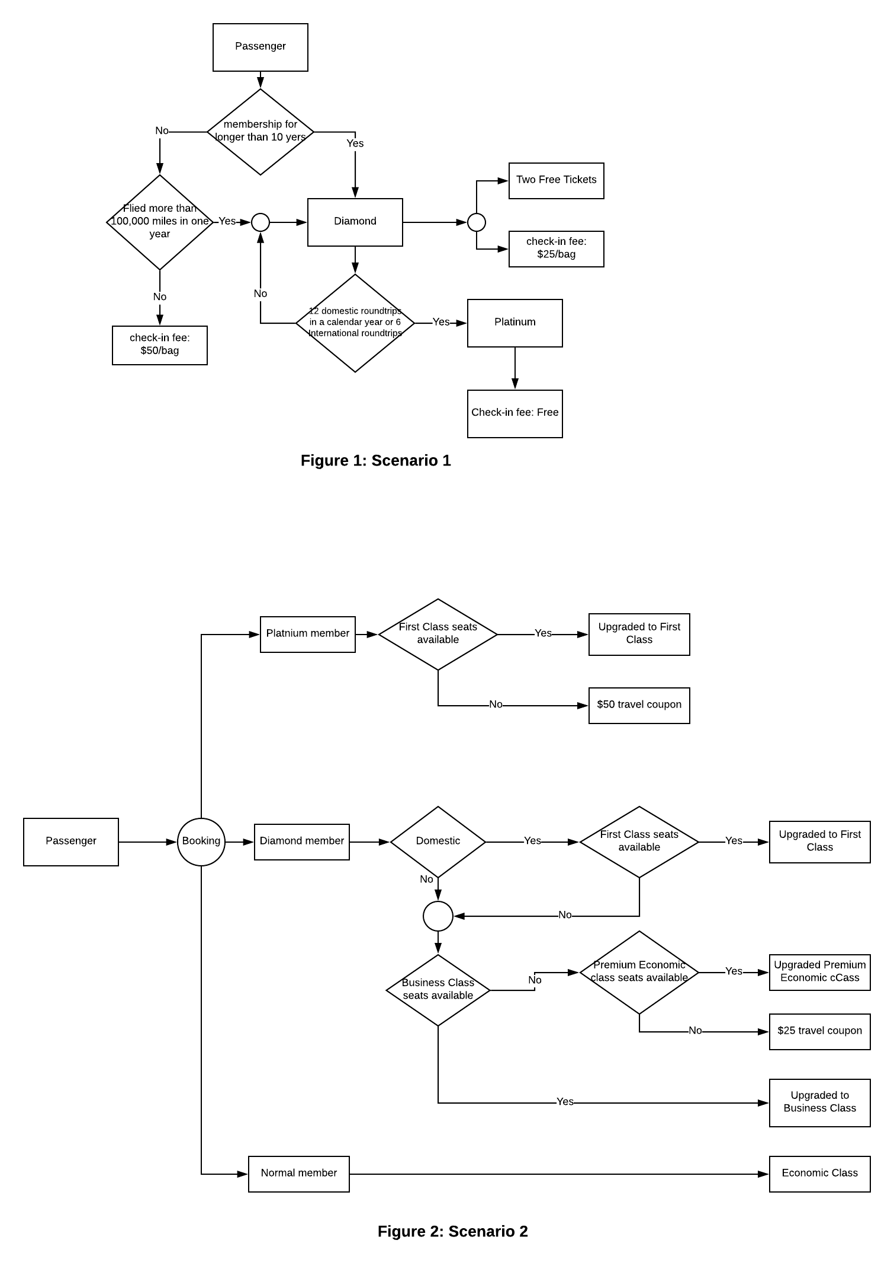

# Decision Tables

Below are two decision tables based on the two different additions the United Airlines frequent flier program. The ‘Y’ symbol in the decision tables represents “yes” implying that the combination possible. On the other hand, “N” symbol in the decision tables represents “no” implying that the combination is not possible. The “-” (dashed) symbol indicate conditions that aren’t reached as part of the particular rule.

**United Airlines New Tiers Decision Table**

|  |  |  |  |  |  |  |  |  |  |
| --- | --- | --- | --- | --- | --- | --- | --- | --- | --- |
| **Conditions** | **Values** | **Rules or Combinations** | | | | | | | |
| **1** | **2** | **3** | **4** | **5** | **6** | **7** | **8** |
| Have been a member of the program for longer than 10 years | **Y, N, -** | Y | Y | N | N | - | - | - | - |
| Have flown over 100,000 miles in a year | **Y, N, -** | Y | N | Y | N | - | - | - | - |
| Have flown 12 domestic round trips within a single calendar year (Jan. - Dec.) | **Y, N, -** | - | - | - | - | Y | Y | N | N |
| Have flown 6 international round trips | **Y, N, -** | - | - | - | - | Y | N | Y | N |
| **Actions** |  |  |  |  |  |  |  |  |  |
| Diamond membership and 2 free tickets to any destination | **Y, N, -** | Y | Y | Y | N | - | - | - | Y |
| Pay ½ price for the baggage check-in fee | **Y, N, -** | Y | Y | Y | N | - | - | - | Y |
| Platinum Membership | **Y, N, -** | - | - | - | - | Y | Y | Y | - |
| Check-in a baggage for free | **Y, N, -** | Y | - | - | - | Y | Y | Y | - |
| Pay full price ($50/bag) for baggage check-in fee | **Y, N, -** | - | - | - | Y | - | - | - | - |
| **Checksum** | 8 | 1 | 1 | 1 | 1 | 1 | 1 | 1 | 1 |

**Decision Table: Scenario 1 - Memberships and Bag Check-in Fees**

|  |  |  |  |  |  |  |  |  |  |  |
| --- | --- | --- | --- | --- | --- | --- | --- | --- | --- | --- |
| **Conditions** | **Values** | **Rules or Combinations** | | | | | | | |  |
| **1** | **2** | **3** | **4** | **5** | **6** | **7** | **8** | **9** |
| Diamond Member | **Y, N, -** | Y | Y | Y | Y | Y | Y | Y | - | - |
| Platinum Member | **Y, N, -** | - | - | - | - | - | - | - | Y | Y |
| Domestic Trip | **Y, N, -** | Y | Y | Y | Y | N | N | N | - | - |
| First Class Seats Available | **Y, N, -** | Y | N | N | N | - | - | - | Y | N |
| Business Class Seats Available | **Y, N, -** | - | Y | N | N | Y | N | N | - | - |
| Premium Economy Class Seats Available | **Y, N, -** | - | - | Y | N | - | Y | N | - | - |
| **Action** |  |  |  |  |  |  |  |  |  |  |
| Upgrade to first class | **Y, N, -** | Y | N | N | N | - | - | N | Y | N |
| Upgrade to business class | **Y, N, -** | - | Y | N | N | Y | N | N | - | - |
| Upgrade to premium economy class | **Y, N, -** | - | - | Y | N | N | Y | N | - | - |
| $50 travel coupon | **Y, N, -** | - | - | - | - | - | - | - | - | Y |
| $25 travel coupon | **Y, N, -** | - | - | - | Y | - | - | Y | - | - |
| Economy class | **Y, N, -** | - | - | - | Y | - | - | Y | - | Y |
| **Checksum** | 8 | 1 | 1 | 1 | 1 | 1 | 1 | 1 | 1 | 1 |

**Decision Table: Scenario 2 - Memberships and Seat Upgrades**

# Scenarios Examples

|  |  |  |  |
| --- | --- | --- | --- |
|  | **Description** | **Decision Table Path** | **Outcome** |
| 1 | Charlie is a businessman who has been travelling with UAL for over 12 years. This year, he also traveled to Mexico and Canada a total of 10 times. He needs to go to New York in three days. UAL is very underbook this week so every seat has availability. | * **Figure 1 - Scenario 1**   + Check condition if the number of years that Charlie has flown is > **10 years.**   + Check condition if Charlie has flown at least **12** **domestic** round trips in a year or at least **6 international** round trips.   + Check condition for Baggage Fee check-in. * **Figure 2 - Scenario 2**   + Determine if Charlie is Platinum or Diamond Member.   + Check if First Class seating is available.   + Check condition for upgrade or coupon. | * Charlie is a Platinum member. * Baggage check-in fee is free. * Upgraded to First Class seating. * Qualifies for 2 free tickets. |
| 2 | Kyle is a CEO of company Z who travels with UAL frequently and has accumulated over 128,300 mile points. He will be traveling to China for a new business agreement. Since it is during thanksgiving holiday, UAL has no seats available on Business and Premium Economy classes. | * **Figure 1 - Scenario 1**   + Check condition if Kyle has travelled over 100,000 miles.   + Check condition if Kyle has flown at least 12 domestic round trips or 6 international round trips in a year. * **Figure 2 - Scenario 2**   + Check condition if Kyle is a Platinum Member or Diamond Member.   + Check if Kyle is going to a Domestic trip or not.   + Check for any available seat on Business Class.   + Check for any available seats on Premium Economy Class. | * Kyle is a Diamond member. * Qualifies to receive 2 free tickets. * Baggage check-in fee is $25 per baggage. * Unable to obtain any seat upgrade due to unavailability. * Therefore, Kyle will receive a $25 travel coupon. |
| 3 | Raghav is a student at San Jose State University who has to fly to Los Angeles tomorrow to attend a food event. He bought a UAL boarding pass because it was the cheapest airlines he could find. This is his first time flying with UAL. There are available seats in all flying classes. | * **Figure 1 - Scenario 1**   + Check condition if Raghav has been a member for the program for longer than 10 years.   + Check condition if Raghav has flown over 100,000 miles.   + Check condition if Raghav has flown at least 12 domestic round trips within the past single calendar year or 6 international round trips.   + Check condition if Raghav is a Platinum or Diamond member to determine his baggage check-in fee. * **Figure 2 - Scenario 2**   + Determine if Raghav is Platinum or Diamond Member.   + Determine if Raghav is flying Domestic.   + Check condition if any seats on the plane are available.   + Determine Raghav’s seat upgrade situation. | * Raghav is a normal member. * Baggage check-in fee is $50 per bag. * No seat upgrade. * Will fly Economic Class. |

# 

# Lessons Learned

There were many lessons that our team learned during this project. The first lesson that our team learned was the importance of Functional Testing and how effective the technique of Decision Tables are. Another lesson that our entire team learned was how to generate a workflow diagram based off airline information. We adapted to the Lucidchart software in order to create the flow diagram. Something else that our team also learned was how to create a decision table based off the United Airlines new frequent flier program. By creating a decision table we learned how to decide each condition, action, and calculate the checksum for each scenario. Lastly, we also practiced how to create scenarios based off of test case outcomes.